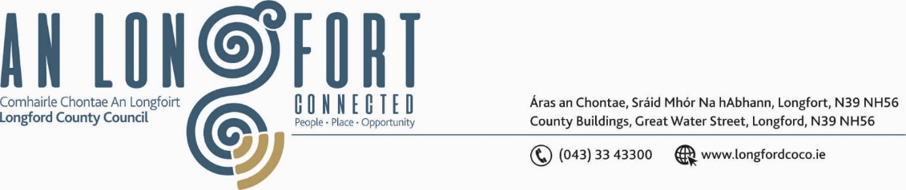

***BALLYMAHON MUNICIPAL DISTRICT***

***Please note meeting will be held via Microsoft Teams and in the Council Chamber.***

**24 October 2024**

**To: Each Member of Ballymahon Municipal District.**

**Dear Member,**

You are requested to attend a Meeting of Ballymahon Municipal District to be held

**in the Council Chamber, Aras an Chontae and via Microsoft Teams** on **Thursday 31 October 2024 at 4pm** to transact business, as set out on the agenda hereunder.

**Yours sincerely**,

_______________

**Claire McNabola,**

**Meetings Administrator.**

**AGENDA**

Prayer before meeting.

1. Consideration of the 2025 General Municipal Allocation.
2. Multi-Annual (3-year) Restoration Improvement Programme